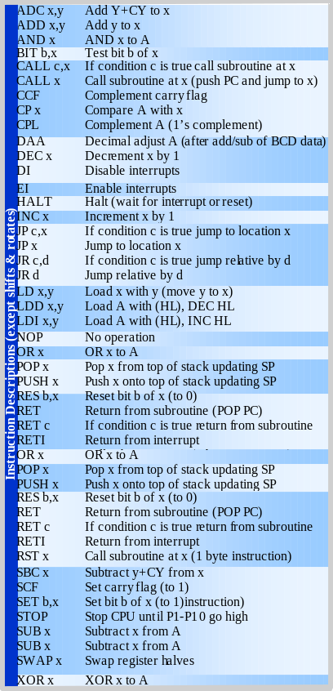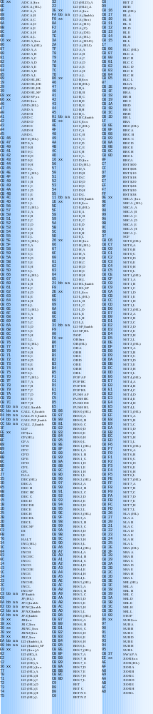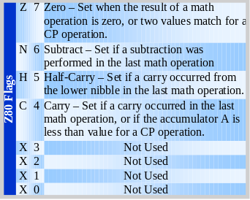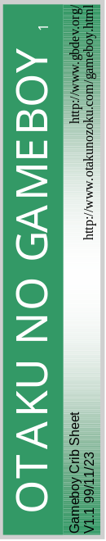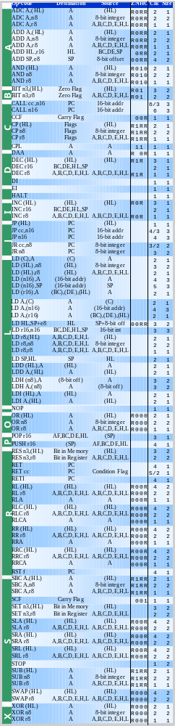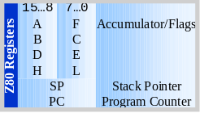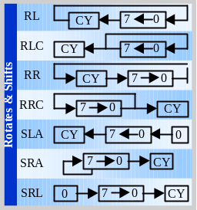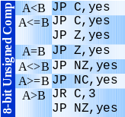

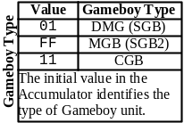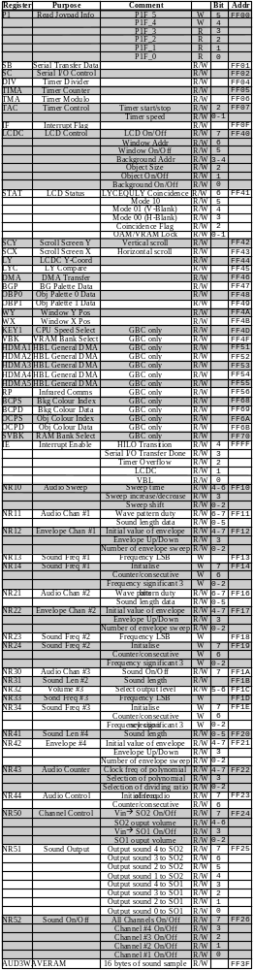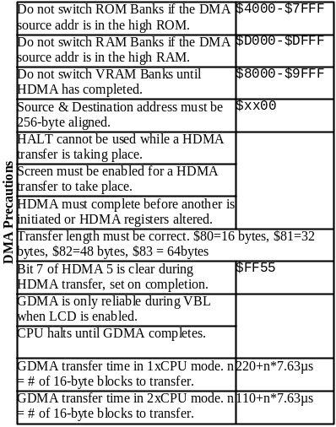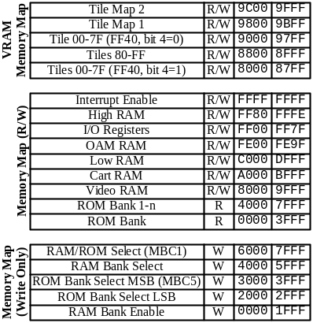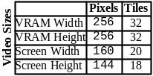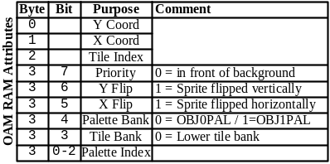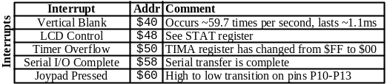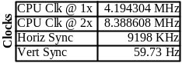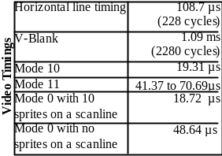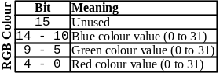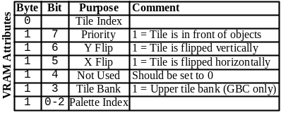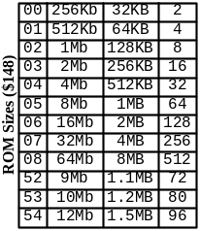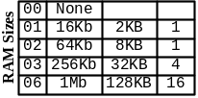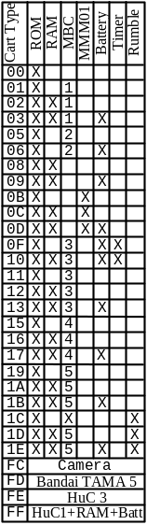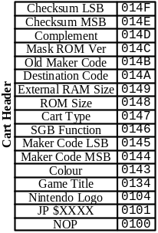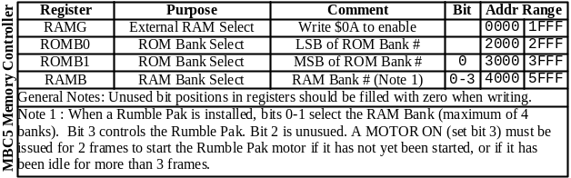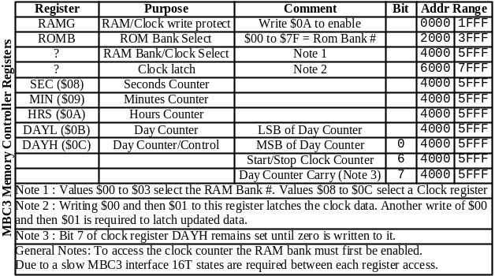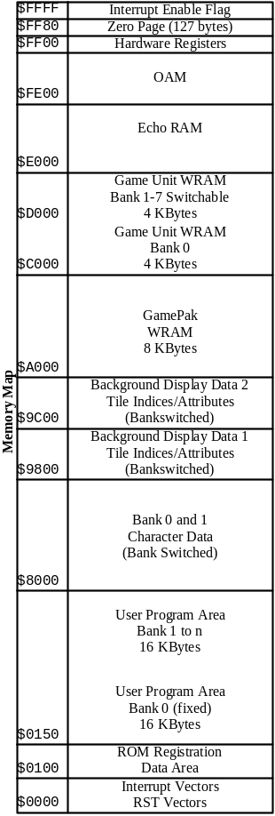
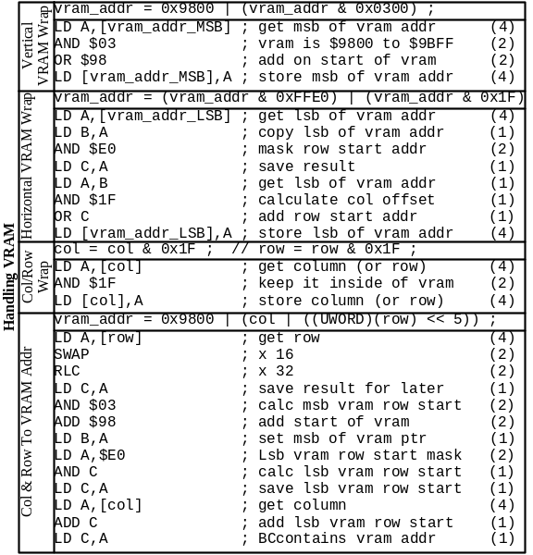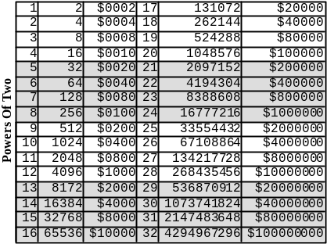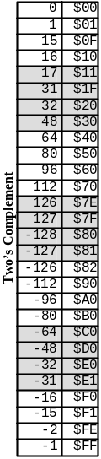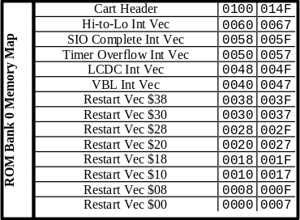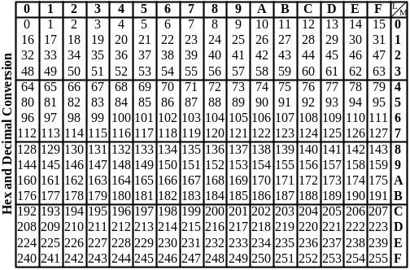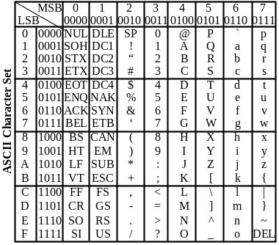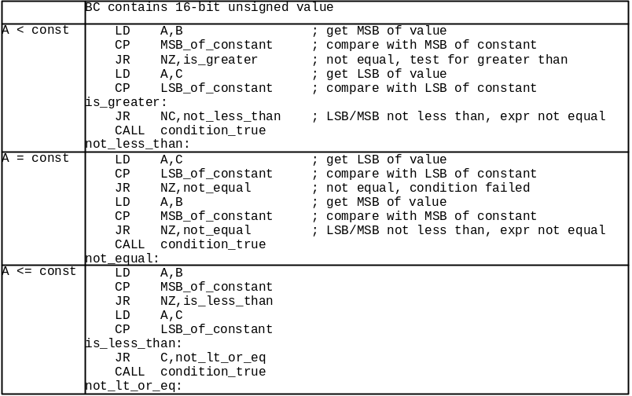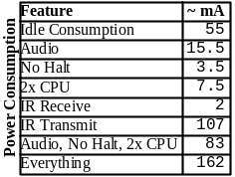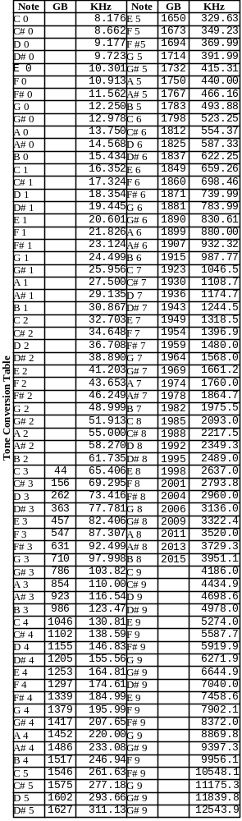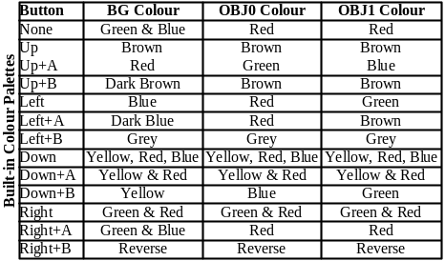
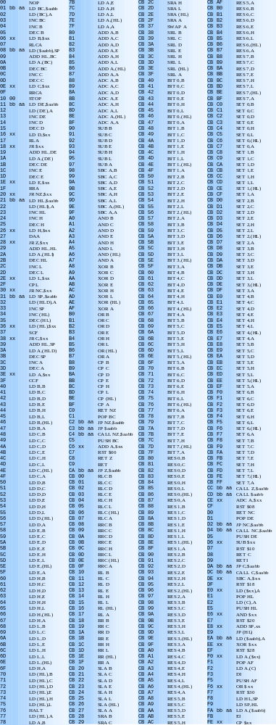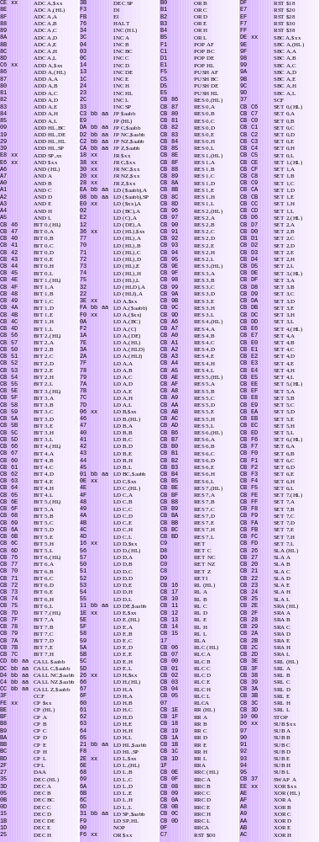

If you want the Crib Sheet then send a short, polite, e-mail to me directly, DO NOT! DO NOT! DO NOT! DO NOT! e-mail the list with your request. The address is otaku@weirdness.com.
If you've already requested the Crib Sheet in the past then the latest version will be sent to you automatically within a few hours.

Gameboy Crib Sheet contains:
List of Gameboy Z80 op-codes with timings, sizes
Z80 registers & flags
Visual description of shift & rotate operations
Code for 8-bit unsigned compares
Two’s complement table
Powers of two table
Hex to Decimal/Decimal to Hex conversion table
ASCII character set
Gameboy interrupts
Complete list of all known Gameboy registers
Code for handling VRAM
Cartridge header information, including RAM Sizes, all known ROM sizes up to 64MBit, all MBC types and features
Video timings
Miscellaneous Gameboy timings
Memory Map
OAM RAM ordering (v0.7)
MBC3 registers (v0.8)
MBC5/Rumble Pak registers (v0.8)
Power consumption (v0.8)
RGB colour format (v0.9)
Attribute fields for VRAM Tiles (v0.9)
Sound tone tables (v0.9)
Complete Gameboy Z80 variant op-code list with hex values (v1.0) new
Built-in colour palette combinations (v1.0) new
Gameboy unit identification (v1.0) new
Memory map (v1.0) new
Now in Colour (v1.1) new

Things to add:
Z80 code for 16-bit unsigned/signed compare operations
Z80 code for 8-bit signed compare operations
Meaning of GB/DMG/GBC flags at $143
List of all known manufacturers.
Clocks per HBL (228 cycles per line)
Clocks per VBL (10 horizontal lines, with 228 cycles per line, total of 2280 cycles (maybe more))
Tile map layout for bank 0 & 1 (showing attributes & indices)
Tile data layout for bank 0 & 1 (showing format of bytes and addresses & indices)
OAM DMA register explanation
HDMA register explanation
GDMA register explanation
Source code for switching CPU speed
Op-code table sorted on op-code hex value (this is in addition to the two op-code tables already)

List of known bugs:
External RAM Size Table is probably incorrect.
Explanation of 0x146 is probably incorrect.
Explanation of 0x143 needs to be clarified.
VRAM Memory Map should say “Tiles 00-7F”.
Source & Destination address should 16-byte aligned in “DMA Precautions”
DMA size is given for HDMA’s, make note about the high bit.
DMA should be 16-byte aligned, not 256-byte.
$FF80 should say “Zero Page RAM” in the “Memory Map”
$E000 should say “Echo RAM -- Not useable” in the “Memory Map”
$9C00/$9800/$8000 should say “Bank Switched” in the “Memory Map”

Fixed bugs:
SWAP instruction is not described. (v1.1)
SCX/SCY register explanation is round the wrong way. (v1.1)
LD HL,(SP+e8) instruction is listed incorrectly. (v1.1)
PUSH/POP instructions are only 1 byte. (v1.1)

Use:
The Gameboy Crib Sheet is designed specifically for printing on a high quality laser or inkjet printer. The Crib Sheet is not designed to be viewed on-screen.

To obtain the best results from printing make sure you use the best quality paper you can obtain that has minimum bleeding. The “High Gloss” is usually the best choice but you must be sure to remove the sheet from the printer the moment it has finished printing and allow it to dry for several minutes to prevent smudging.

Notes:
It is only available in Adobe PDF format and will probably never be converted to HTML, so don’t ask.

Also available:
EverQuest crib sheet (currently being worked on)
ThreeD Crib Sheet (contains information for 3D computer graphics)

Undocumented features
Sprite bugs
Value at $143 is $80 = GBC compatible game

Value at $143 is $C0 = GBC dedicated game
All other values at $143 indicate a regular GB game.

The ram size does not comply with the one from Nintendo as far as I can see.
From Nintendo CGB User's Guide:
External RAM Size (0149H)
Store the code for the size of external RAM installed in the cartridge.
Address 149 RAM Size
00H No RAM or MBC2
01H -------
02H 64 KBit
03H 256 KBit
04H 1 Mbit
You write that 0146 is Game Unit Code: Nintendo says:
Store the Function Code for the game program. Use the table below.
0146H Super Game Boy Function
00H Game Boy (will also run on Super Game Boy)
03H Uses Super Game Boy Functions
CGB Compatibility Code (0143H)
Store the code which distinguishes between games that are CGB (Game Boy Color) compatible, and those that are not.
Address 143H Denotation
00H CGB Incompatible
80H CGB Compatible
C0H CGB Exclusive
CGB Incompatible: A program which does not use CGB functions, but operates
with both CGB and DMG (Monochrome).
CGB Compatible: A program which uses CGB functions, and operates with both
CGB and DMG.
CGB Exclusive: A program which uses CGB functions, but will only operate on a Game Boy Color unit (not on DMG/MGB). If a user attempts to play this software on Game Boy, a screen must be displayed telling the user that the game must be played on Game Boy Color.
Extra info from Nintendo's doc:
Game Code (013FH~0142H)
Please enter the 4 character Game Code in hexadecimal format which has been assigned to your software title by NOA.
For example,
If the Game Code is "APCJ",
Address 013FH = 41H ('A')
Address 0140H = 50H ('P')
Address 0141H = 43H ('C')
Address 0142H = 4AH ('J')
This requirement only applies to new titles. If the program is changed and a master ROM resubmitted for a game title which has already been marketed, it is not necessary to insert a game code for this submission. (If the Game Code is added to an existing game, please be aware of potential problems with software verification routines in serial communication protocols or GB Pak routines. For example, the Game Titles for the old version and the new version MAY be different, causing the new version to be unrecognized by the software verification routine.)
The vblank is 10 lines with 228 cycles on each line.

